BotVault

WHO: David & Jun
WHAT: Final Project
WHERE: CSC318
WHEN: Due by course completion
WHY: Show understanding of SDLC and design principles

PURPOSE: Create a Desktop Application for Microsoft Windows systems that acts as a “vault” for trading bot information.

Features: Bot Library, Performance/Validation Tracking, Version History, Note Section

Actors: Trader(User)
Developer

Use Case:
- Add Bot File
- Delete Bot
- Search/Filter Bots
- Manage Versions
- Store Performance Metrics
- Export Bots
- Tag Bot Status

Functional Requirements:
- Create bot metadata; think hashing
- Attach the bot code
- Be able to pull out the code
- Edit bot attachments
- Delete a bot
- Search and filter bots
- Sort bots?
- Display bot data (pop up box)
- Tag bots for status (in development, finished, etc)
- Store multiple versions of bots
- Persist all data locally using NoSQL

Non Function Requirements:
- Performance: Search across bot library provides results in under 500ms
- Usability: Able to upload a bot with its code in under 5 clicks
- Integrity: Stored bots are verified against hash
- Portability: Can run on Windows 11/10
- Availability: Has availability without any internet connection
- Recoverability: User can export vault

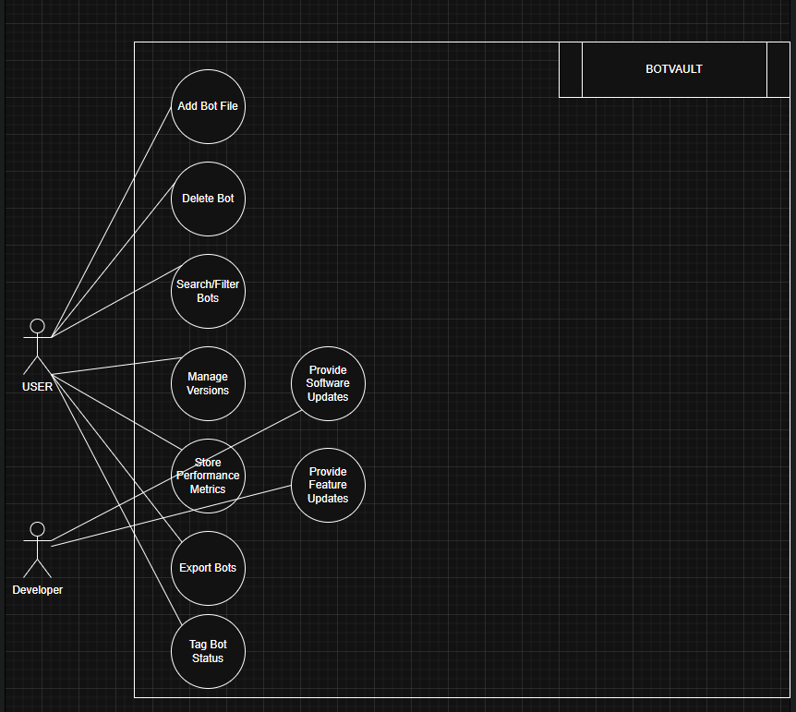

ERD diagram of SQL
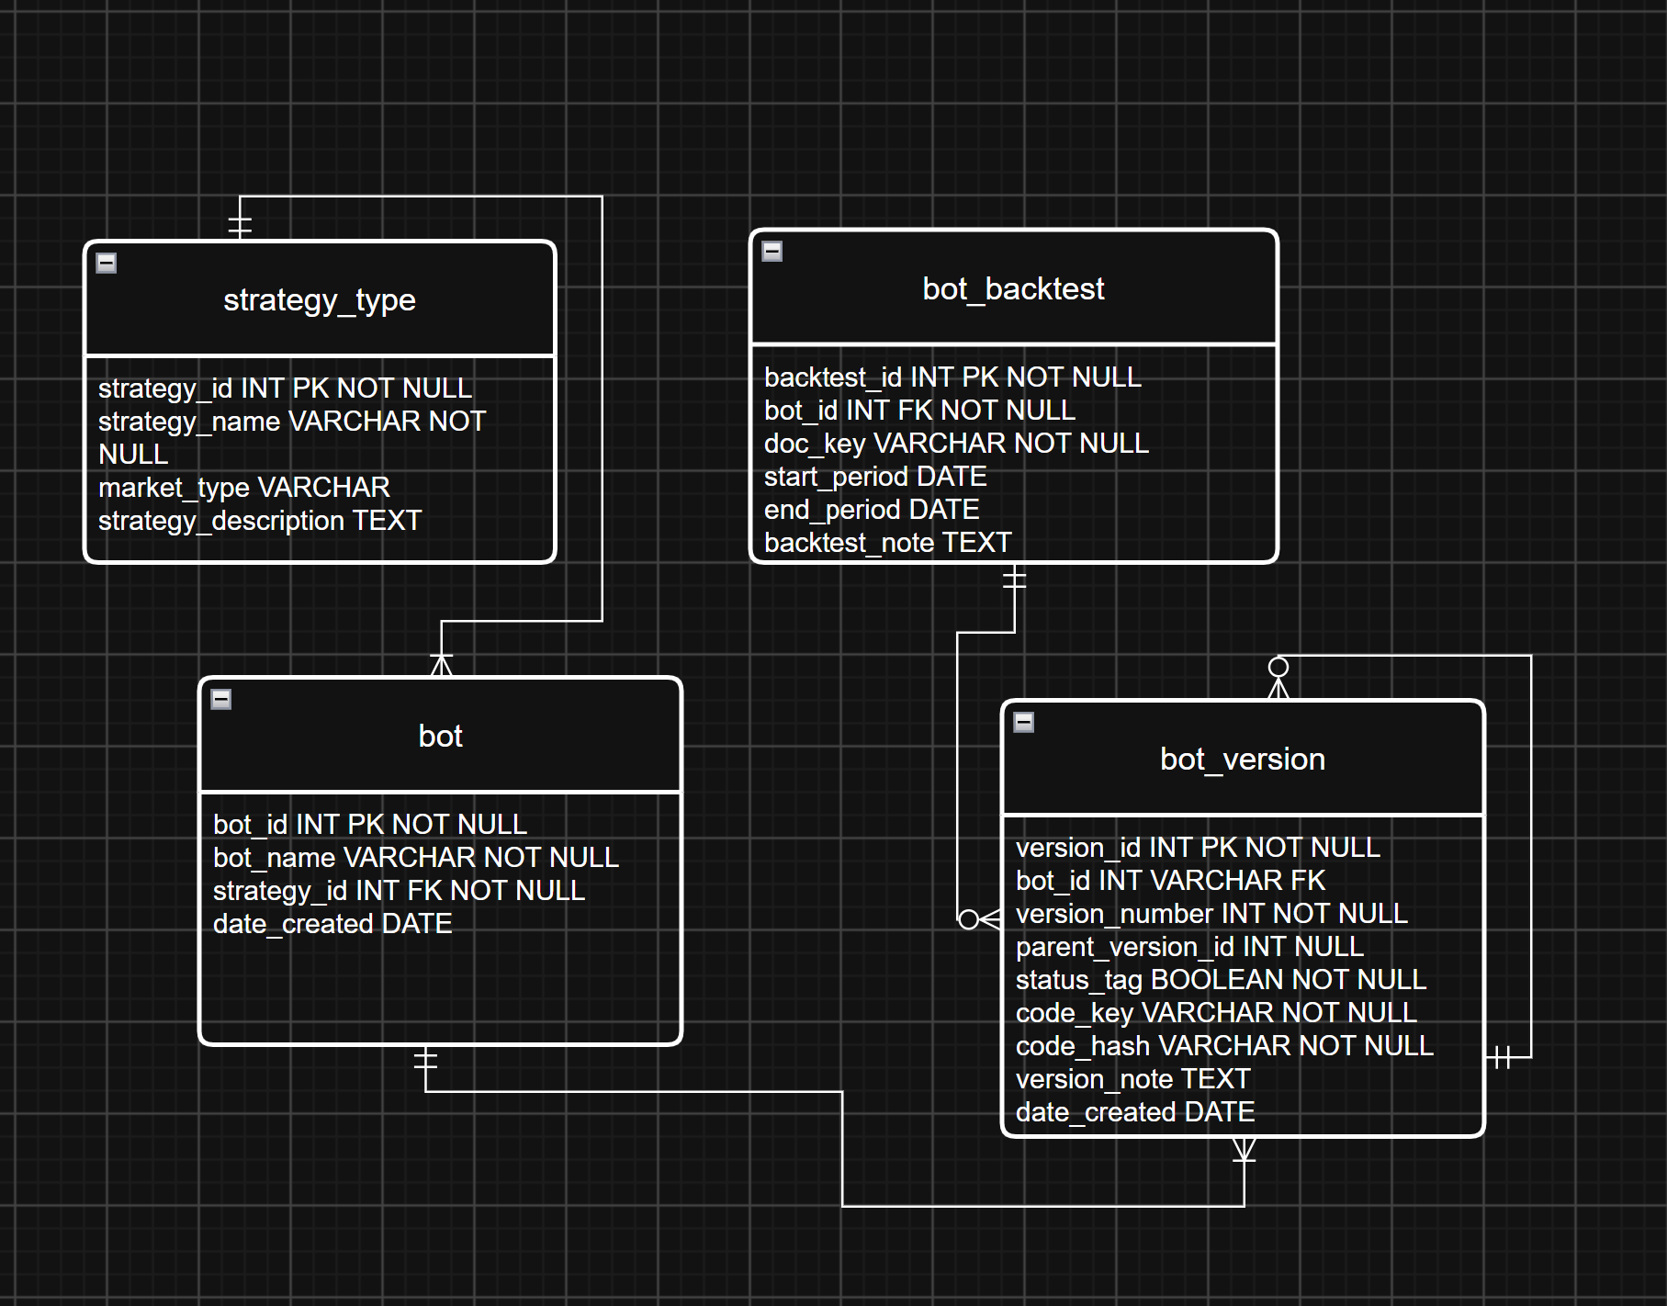

- Strategy table will hold data such as discretionary, non-discretionary, forex, futures, stocks etc
- Bot table will hold simple data regarding the bot
- Bot_version table will hold the version number, code_key is NoSQL key to retrieve code, status (whether its running or not), code_hash is the integrity digest used to verify corruption or duplication.
- Bot_backtest table will hold the doc_key for retrieving backtest documents from NoSQL and descriptive data.
- Bot_performance will hold key metrics regarding a backtest.

SQL database – SQLite
NoSQL database – LMDB
Both databases has python library or package.

Implementation Notes — Deviations from Original ERD (2026-08-04)
- bot_version.status_tag was implemented as a TEXT enum ("in development" / "finished" / "shelved") instead of the ERD's boolean, with a matching version_note field -- both scoped to a bot's current head version, not the bot as a whole.
- The bot_performance table was removed entirely. Performance data lives inside backtest documents stored in LMDB (raw content) rather than structured SQL columns; bot_backtest (doc_key, start/end period, note) is kept.
- Dedup rule for re-uploading code: if the new file's hash matches the bot's current head version, it's a no-op (no new version, no new storage write). If it matches an older, non-head version (an intentional revert), a new head version is still created.
- bot_version.source_filename was added (not in the original ERD) so the correct file extension can be restored when code is exported back out.
- Code is stored content-addressed: the storage key is the sha256 hash of the file bytes, which gives free, correct dedup -- identical code reused across different bots is only stored once. Backtest documents are NOT content-addressed (a fresh id per row), since backtest documents are unlikely to be byte-identical across bots.
- Application data (the relational database and the code/document blob store) lives in the standard per-user application-data folder, not inside the project/source folder -- keeping source and user data independent.
- strategy_type is seeded on first run (idempotent) with the example list from this document (discretionary, non-discretionary, forex, futures, stocks) so the first "Add bot" flow doesn't force the user to invent a strategy type immediately.

